Safety, Health & Environment Policy
Sugar Terminals Limited

STL recognise the impact that our operations can have on people and the environment. We are committed to safeguarding the health, safety and welfare of all people working for, or on our behalf, and protecting the environment from potential impacts resulting from our activities.

To fulfil this commitment, STL will:
- Provide a safe working environment
- Ensure that effective SHE management systems are in place
- Continuously improve our SHE systems, processes and performance
- Consistently demonstrate and promote visible leadership in safety
- Minimise our potential environmental impacts and promote the sustainable use of natural resources in our operations
- Respond effectively to emergencies and incidents
- Work collaboratively with contractors and other stakeholders
- Comply with all legal, regulatory and other obligations
- Ensure its staff and contractors are accountable to these commitments and behave in a safe and environmentally responsible manner at all times

Through demonstrating leadership, building on our current efforts, learning from incidents, and continually improving our performance and systems, together we can achieve our goal of safeguarding our people and the environment in which we operate.
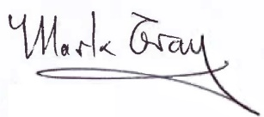

David Quinn Mark Gray
Chief Executive Officer Chair

